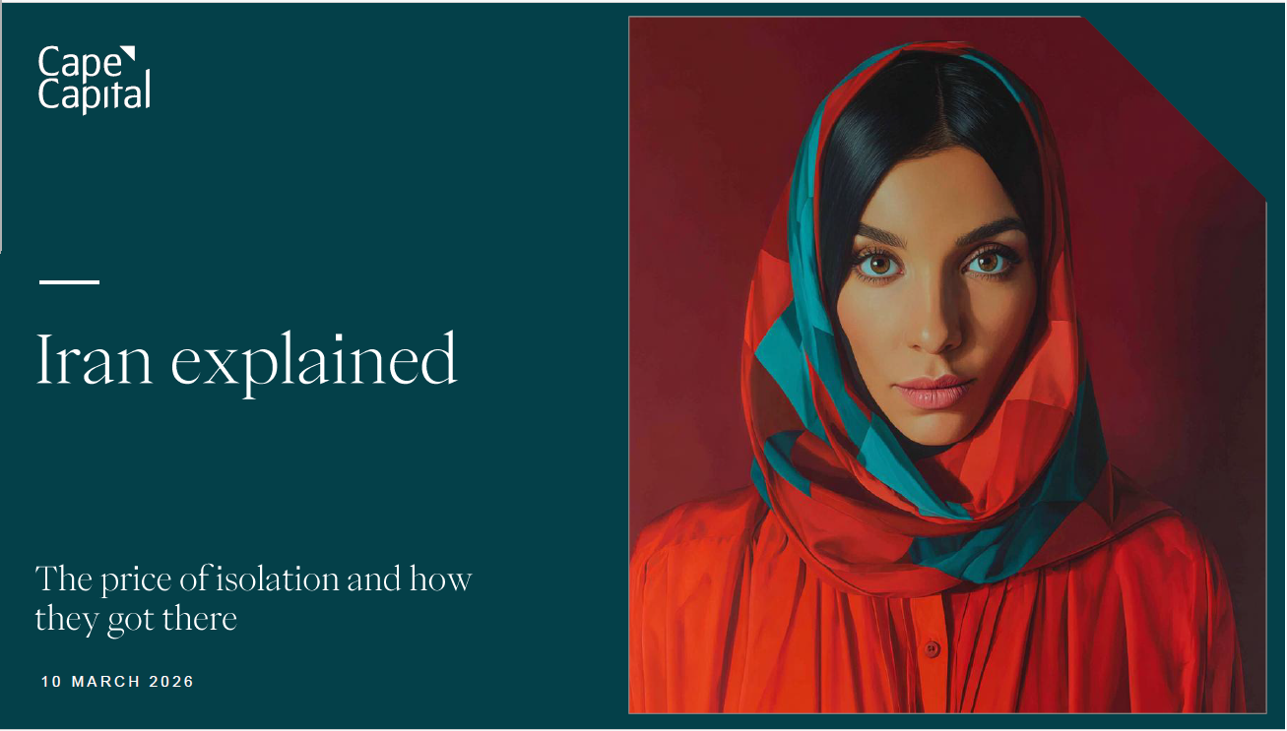

Iran explained -- Presentation has been added to the usual folder (in pptx and in pdf): Publications - Cape Thematic Research - All Documents
This one pager can be found
Production - Cape Thematic Research production - One pager - All Documents
- Country fundamentals: GDP USD 437bn (2024), 92.4m population (median age 33, 77% urban, 94% literacy), 42% inflation, 22% youth unemployment. Services 51% of economy, oil 23%.
- Terrain and warfighting constraints: Iran's mountainous geography makes large-scale ground operations extremely costly and impractical, pushing adversaries toward air campaigns instead. Repeated bombing (7,000+ strikes so far) over and around densely populated areas like Tehran (8m inhabitants) risks severe civilian casualties and large-scale internal displacement, with knock-on effects for regional stability and refugee pressures.
- Nuclear program origins: Started 1957 via US "Atoms for Peace"; Iran-Iraq War (1980-88) catalyst when Iraq used chemical weapons. Covert enrichment via Pakistan's A.Q. Khan network. Iran views nuclear capability as ultimate deterrence against regime change and regional hegemony tool.
- Energy paradox: Holds 3rd largest oil reserves (209bn barrels) and 2nd largest gas reserves (1,200 Tcf), yet ranks only 9th and 3rd in production due to decades of underinvestment and sanctions. Chronic infrastructure decay despite sitting on world-class deposits.
- China dependency asymmetry: China absorbs 80%+ of Iran's oil exports (~1.4 mb/d) at USD 8-10/barrel discount to Brent, but this represents only 13% of China's seaborne imports. Iran needs China far more than China needs Iran—Beijing holds quiet leverage for nuclear concessions.
- Strait of Hormuz chokepoint: ~20 million barrels/day (20% of global oil) and 1/5 of global LNG flows through two 3km-wide shipping lanes. 84% goes to Asia (China, India, Japan, South Korea). Bypass pipelines handle only 3.5 mb/d (17% of flow). Any disruption could push oil above USD 100/barrel.
- Aviation and fuel costs compounding: Iran/Iraq airspace closures force rerouting (adds 45min-4hrs per flight, 15% more fuel burn). Combined with Ukraine no-fly zone, leaves only narrow southern corridors. Brent crude up 30% YTD; fuel is 25-35% of airline operating costs. Emirates, Qatar Airways, Etihad hubs severely restricted (~90,000 passengers/day affected).
- Air defence supply constraints: Patriot system (Raytheon/Lockheed) produces only ~12 systems and ~620 missiles/year (planning 2,000). Cost USD 4-5m per missile. US holds only 25% of needed missile stock—a year's production could be exhausted in days of sustained conflict.
- Regional proxy network: IRGC (Islamic Revolutionary Guard Corps) reports directly to Supreme Leader, operates parallel military structure funding conflicts in Iraq, Syria, Lebanon, Yemen. Rare domestic political consensus (hardliners and reformists) on enrichment rights.
- Normalization scenario: If Iran were to democratize, consequences transformative: proxy wars collapse, nuclear standoff ends, 209bn barrels oil and 1,200 Tcf gas fully open to investment, 92m educated population unleashed. Iran becomes bridge between Middle East and Asia, not barrier.

